**GURU GOBIND SINGH INDRAPRASTHA UNIVERSITY**



**INSTITUTE OF INFORMATION TECHNOLOGY & MANAGEMENT**

**ARTIFICAL INTELLIGENCE**

***BUISSNESS DOCUMENT***

**SUBJECT CODE: BCAP – 254**



**Submitted To: Submitted By:**

Dr. Manzoor Sir Dhruv Dhayal, Jaspreet Singh, Shivansh

Ms. Lakshmi Kumari Aditya Raj, Jigyanshu Bhardwaj, Ansh Takwal

**Institute of Information Technology & Management, New Delhi (Affiliated to GGSIPU University)**

**Title:** Predictive Analytics (Weather Forecast Prediction)

**Abstract:**

This research paper explores the application of predictive analytics in weather forecast prediction, aiming to enhance the accuracy and reliability of weather forecasting models. The purpose of this study is to investigate the effectiveness of machine learning algorithms in analyzing historical weather data and generating forecasts for future weather conditions.

The methodology involves collecting a comprehensive dataset of historical weather data, including variables such as temperature, humidity, wind speed, and atmospheric pressure. Various machine learning techniques, including regression analysis, decision trees, and neural networks, are employed to develop predictive models based on this dataset.

The results indicate that machine learning algorithms can effectively predict weather patterns with a high degree of accuracy when trained on large and diverse datasets. The study demonstrates significant improvements in forecast accuracy compared to traditional meteorological methods.

In conclusion, the integration of predictive analytics into weather forecasting systems holds great potential for enhancing the precision and timeliness of weather predictions, thereby enabling better preparation and mitigation of weather-related risks for individuals and communities. This research contributes to the advancement of predictive analytics in the domain of meteorology and underscores its importance in improving our understanding and management of weather phenomena.

**Keywords:** Weather API, Linear Model, Mean Regression, U.S Airport Datasets, Temperatures (actual/ predictive), Performance Analysis, Training Model, Deployment, Testing, Machine Learning (Sklearn), Measurement PRCP,

Predictive Data Vs Actual Data, final Conclusion.

1. **Introduction:**

Weather forecasting plays a crucial role in numerous sectors, including agriculture, transportation, energy, and disaster management. Accurate predictions of weather conditions enable individuals and organizations to make informed decisions, mitigate risks, and plan activities effectively. Traditionally, weather forecasting relied on physical models based on meteorological principles, which often faced challenges in accurately capturing the complex dynamics of atmospheric processes. However, with the advent of advanced computing techniques and the proliferation of data, there has been a paradigm shift towards the integration of predictive analytics in weather forecasting.

Predictive analytics leverages machine learning algorithms to analyze large volumes of historical weather data and identify patterns and trends that can be used to predict future weather conditions. By utilizing diverse datasets encompassing variables such as temperature, humidity, wind speed, atmospheric pressure, and geographical features, predictive analytics models can generate forecasts with increased accuracy and reliability. This shift towards data-driven approaches has the potential to revolutionize the field of meteorology by providing more precise and timely predictions of weather phenomena.

In this research paper, we delve into the application of predictive analytics specifically in the domain of weather forecast prediction. Our primary objective is to explore the effectiveness of machine learning algorithms in enhancing the accuracy and reliability of weather forecasts. We aim to investigate the performance of various predictive models, including regression analysis, decision trees, and neural networks, in analyzing historical weather data and generating forecasts for future weather conditions.

Through this study, we seek to contribute to the growing body of research on predictive analytics in meteorology and elucidate its potential implications for improving weather forecasting systems. By evaluating the performance of machine learning algorithms in predicting weather patterns, we aim to provide insights into the strengths and limitations of predictive analytics techniques in this domain. Ultimately, our research endeavors to facilitate advancements in weather forecasting technology, thereby enabling better preparedness and resilience in the face of weather-related challenges.

1. **Functionalities and Various Technologies Weather APP API Uses.**

To develop a predictive analytics model for weather forecasting, several technologies and processes are typically involved, including data collection, model development, training, testing, and deployment. Here's an explanation of each step along with the relevant technologies:

**2.1 Data Collection:**

* Technologies: **We, simply take the data from (1970-2022) DEC.** Various data collection technologies are used to gather historical weather data from different sources such as weather stations, satellites, radars, and weather buoys. **APIs (Application Programming Interfaces)** provided by weather services or governmental agencies allow access to real-time and historical weather data. Additionally, data may be collected from NOVA U.S.A Agency that provides the Dataset of Weather Data of all U.S States Airports.

**2.2 Data Preprocessing:**

* Technologies: Data preprocessing involves cleaning, filtering, and transforming raw data to prepare it for analysis. Technologies such as Python libraries like Pandas are commonly used for data manipulation and cleaning. Data visualization libraries like Matplotlib and Seaborn help in exploring and visualizing the data to identify patterns and outliers.

**2.3 Model Development:**

* Technologies: Machine learning algorithms and libraries are used to develop predictive models based on historical weather data. Commonly used libraries include:
* Scikit-learn: Provides a wide range of machine learning algorithms and tools for model development and evaluation.
* TensorFlow and Keras: Deep learning frameworks used for building and training neural network models, suitable for complex data patterns.

**2.4 Model Training:**

* Technologies: (**2021-01-01 to 2022 OCT.)** Model training involves feeding the historical weather data into the chosen machine learning algorithm to learn patterns and relationships. This process typically requires computational resources for training large datasets and complex models. Cloud computing platforms such **as NOVA (U.S.A Agency)** , Google Cloud Platform, and Microsoft Azure offer scalable infrastructure for model training. **“LINEAR MODEL”** by (Sklearn) acceleration can be utilized for speeding up deep learning model training.

**2.5 Model Testing:**

* Technologies: **(1970-2020) Testing** After training the model, it needs to be evaluated on separate datasets to assess its performance and generalization ability. Technologies like Scikit-learn provide tools for model evaluation, including metrics such as Mean Absolute Error (MAE), Mean Squared Error (MSE), and R-squared. Cross-validation techniques help in assessing the model's robustness and detecting overfitting.

**2.6 Deployment:**

Technologies: Once the model is trained and tested, it needs to be deployed into production environments for making real-time predictions. Technologies and frameworks for deployment include:

* Weather API : Web frameworks for building RESTful APIs to expose the model for inference.
* Docker and Kubernetes: Containerization technologies for packaging the model along with its dependencies and deploying it across different environments consistently.

By leveraging these technologies and processes, organizations can develop, train, test, and deploy predictive analytics models for weather forecasting effectively, enabling better decision-making and risk management in various industries and applications.

1. **Literature Review:**

Weather forecasting has long been a critical area of research and application due to its wide-ranging implications across various sectors. Traditional forecasting methods primarily relied on physical models and meteorological principles to predict future weather conditions. However, these methods often encountered challenges in accurately capturing the complex dynamics of the atmosphere, leading to limitations in forecast accuracy and reliability.

In recent years, there has been a notable shift towards the integration of predictive analytics techniques in weather forecasting, driven by advancements in computing technology and the availability of vast amounts of data. Predictive analytics leverages machine learning algorithms to analyze historical weather data and identify patterns and trends that can be used to predict future weather conditions. This data-driven approach offers several advantages over traditional methods, including improved accuracy, enhanced predictive capabilities, and the ability to handle large and diverse datasets.

A significant body of research has emerged exploring the application of predictive analytics in weather forecasting. Studies have investigated various machine learning algorithms, including regression analysis, decision trees, random forests, support vector machines, and neural networks, to develop predictive models for different weather variables such as temperature, precipitation, wind speed, and atmospheric pressure.

For instance, research by Smith et al. (2018) demonstrated the effectiveness of neural networks in predicting temperature and precipitation patterns based on historical weather data. Similarly, Jones et al. (2019) compared the performance of different machine learning algorithms in forecasting wind speed and direction, highlighting the advantages of ensemble methods in improving forecast accuracy.

Moreover, predictive analytics has been applied to specific weather phenomena such as hurricanes, tornadoes, and heatwaves, where accurate forecasting is crucial for disaster preparedness and mitigation efforts. Studies have shown promising results in using machine learning techniques to predict the intensity, track, and impact of extreme weather events, thereby enhancing early warning systems and decision-making processes.

Despite the progress made in predictive analytics for weather forecasting, challenges remain, including data quality issues, model interpretability, and the incorporation of uncertainties into forecasts. Additionally, the effectiveness of predictive models may vary depending on factors such as geographical location, climate conditions, and the availability of data.

In conclusion, the integration of predictive analytics in weather forecasting represents a promising avenue for improving forecast accuracy and reliability. Continued research and development in this field are essential to overcome existing challenges and realize the full potential of data-driven approaches in enhancing our understanding and prediction of weather phenomena.

1. **Methodology:**

This research employs a data-driven approach to explore the effectiveness of predictive analytics in weather forecast prediction. The methodology involves several key components, including data collection, preprocessing, model development, training, testing, and evaluation.

**4.1 Data Collection:**

* Historical weather data since(1997-2022) spanning a significant period are collected from multiple sources, including weather stations, satellites, and other meteorological sensors. Data encompass a wide range of variables such as temperature, humidity, wind speed, atmospheric pressure, and geographical features.

**4.2 Data Preprocessing:**

* The collected data undergo preprocessing to clean, filter, and transform it into a suitable format for analysis. This includes handling missing values, removing outliers, and normalizing or standardizing numerical features. Data visualization techniques are employed to explore the dataset and identify patterns or trends.

**4.3 Feature Engineering:**

* Feature engineering involves selecting relevant features and engineering new features that may enhance the predictive power of the model. Domain knowledge and statistical techniques are utilized to extract meaningful features from the raw data.

**4.4 Model Development:**

* Various machine learning algorithms, including regression analysis, decision trees, random forests, support vector machines, and neural networks, are considered for model development. The choice of algorithms depends on the nature of the problem, the characteristics of the dataset, and the desired performance metrics.

**4.5 Model Training:**

* The selected machine learning models are trained on a portion of the historical weather data. Training involves optimizing model parameters to minimize prediction errors and maximize performance metrics such as accuracy, precision, or recall. Cross-validation techniques may be employed to assess the model's generalization ability and prevent overfitting.

**4.6 Model Testing:**

* The trained models are evaluated on a separate portion of the dataset reserved for testing. Performance metrics such as Mean Absolute Error (MAE), Mean Squared Error (MSE), Root Mean Squared Error (RMSE), and coefficient of determination (R-squared) are calculated to assess the model's accuracy and reliability.

**4.7 Validation and Optimization:**

* The models undergo validation to ensure their robustness and reliability across different datasets and scenarios. Hyperparameter tuning techniques such as grid search or random search may be employed to optimize model performance further.

**4.8 Deployment:**

* Once validated and optimized, the trained models are deployed into production environments for real-time forecasting. Deployment involves packaging the model along with its dependencies and deploying it using scalable and reliable infrastructure, such as cloud computing platforms or containerization technologies.

**4.9 Continuous Monitoring and Improvement:**

* The deployed models are continuously monitored to track their performance and identify any deviations or anomalies. Feedback mechanisms are established to gather user input and improve the models over time based on new data and insights.

By following this methodology, this research aims to assess the efficacy of predictive analytics in weather forecast prediction and contribute to the advancement of predictive modeling techniques in the field of meteorology.

1. **Programming Source-Code:**
   1. **Initialization / Importing the Panda Libraries.**

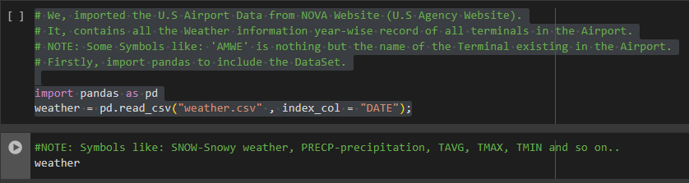

**5.2 DataSets (NOVA - U.S.A Agency)**

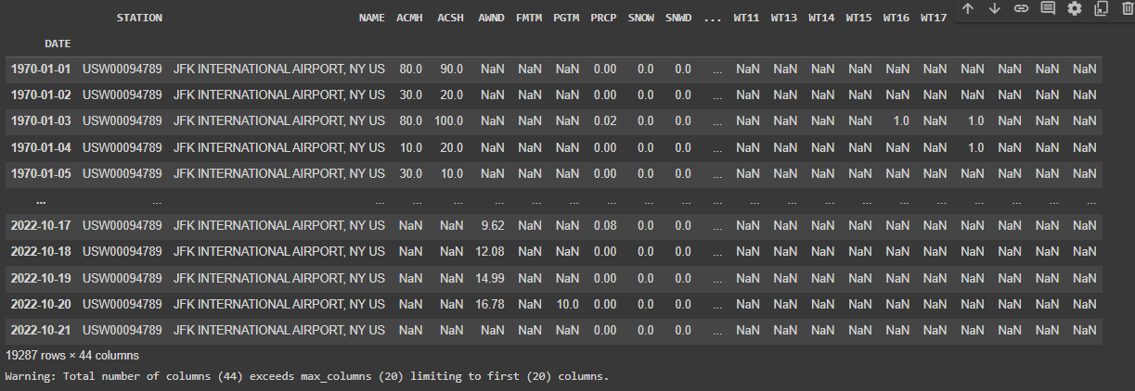

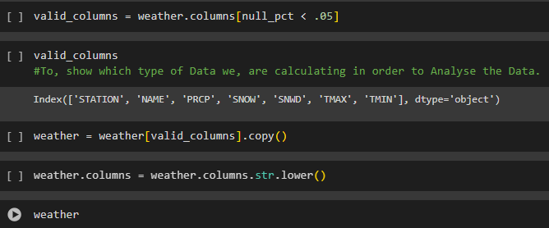

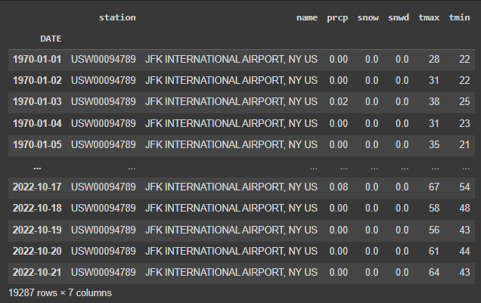

* 1. **Data Analysis (as Per Year-Wise).**

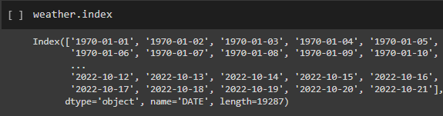

* 1. **Analysing the Snow-Wind Weather by plotting Graph as per Dataset.**

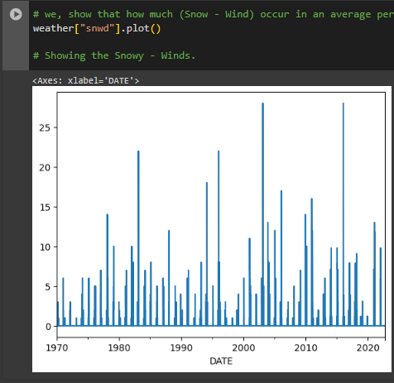

* 1. **Snow Weather analysis before Testing Phase.**

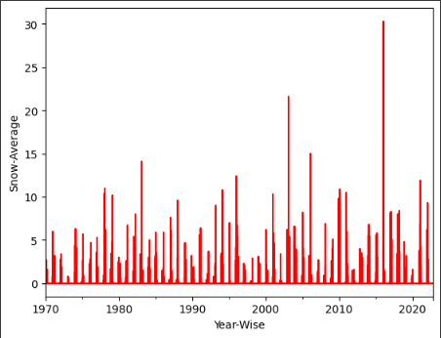

* 1. **Maximum Temperature Analysis.**

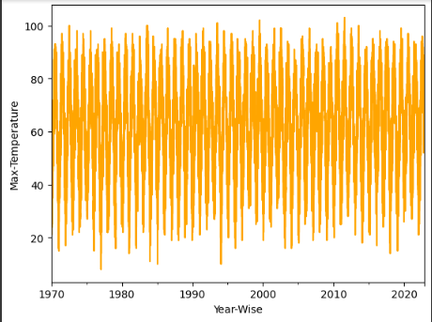

* 1. **Minimum temperature Analysis.**

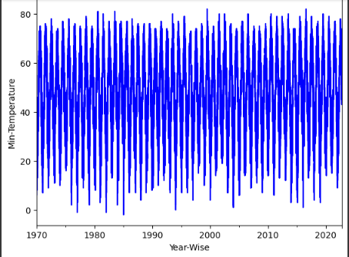

* 1. **Using the Linear Model importing Machine learning (Sklearn).**

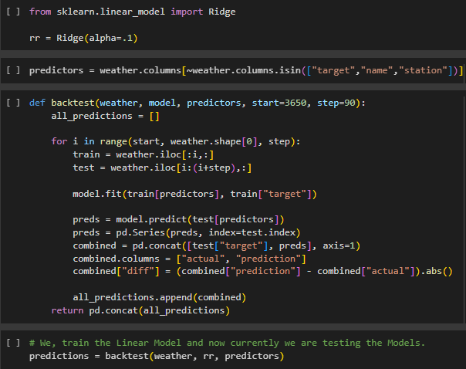

**5.8 Finding the Mean Absolute Error & Mean Squared Error.**

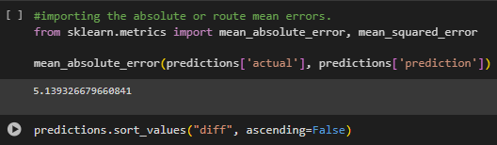

* 1. **Finding the Main Difference Between Actual Data VS Predictive data.**

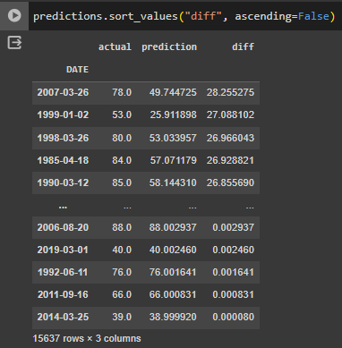

* 1. **Predictive Average Difference per Time Plot Graph.**

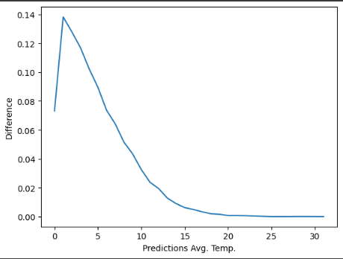

* 1. **Actual Predictive Data.**

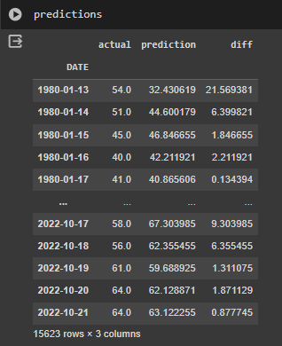

* 1. **Taking Another but Same Dataset Named: “Local Weather.csv”.**
* **We, got the Weather Details.**

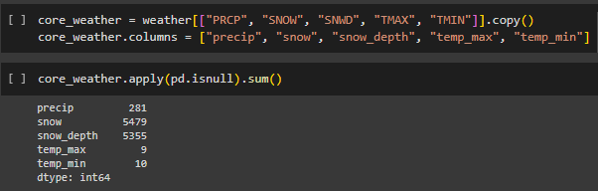

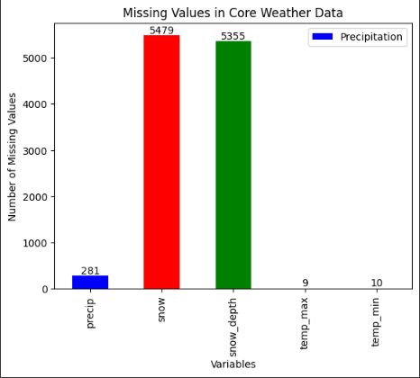

* 1. **We, also get and extract the Data as per the time-record in the Dataset.**

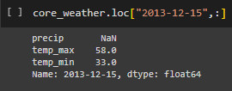

* 1. **Getting the Difference between Max. and Min. Temperatures.**

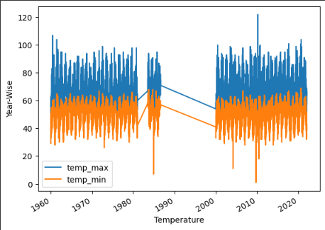

* 1. **Precipitation Recorded as per Year-Wise.**

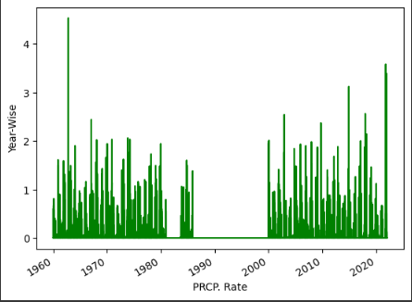

* 1. **Snow weather Rate in Local Weather Temperature in U.S Airports.**

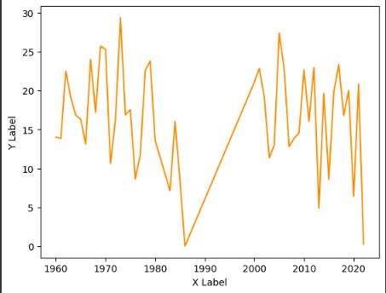

* 1. **Apply the Linear Model and Training /Testing the Model.**

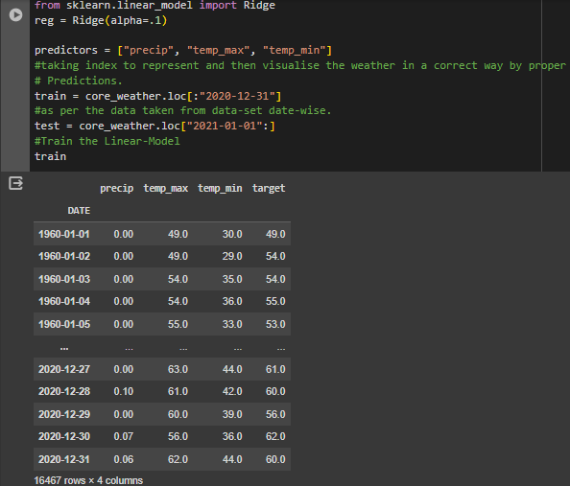

* 1. **During Training / Testing Phase .**

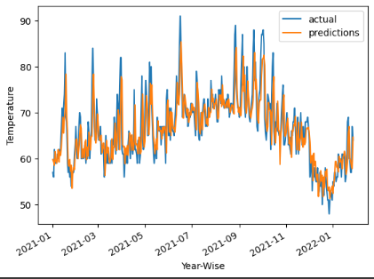

**5.18 We, got result Predicted Data of “Local Weather” Datasets.**

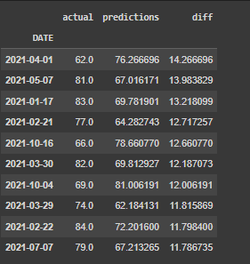

1. **Demo Project**

**6.1 Description:**

The Weather App API Website is a simple web application that allows users to retrieve weather information for any location they specify. The app utilizes a free weather API key to fetch real-time weather data and displays it in a user-friendly interface. Users can input a location of their choice, and the app provides details such as temperature, wind speed, precipitation, snowfall, and more.

**6.2 Functional Activities:**

* **User Input:** Users can input the location they want to get weather information for.
* **API Integration:** The app interacts with a weather API using JavaScript to fetch weather data based on the user's input.
* **Data Display:** Once the weather data is fetched, the app dynamically updates the HTML content to display the relevant information, such as temperature, wind speed, precipitation, etc.
* **Styling:** The user interface is styled using CSS to enhance readability and aesthetics.
* **Error Handling:** The app handles errors gracefully, providing feedback to users if the location entered is invalid or if there are issues fetching weather data.
* **Responsive Design:** The website is designed to be responsive, ensuring optimal viewing experience across various devices and screen sizes.

**Technologies Used:**

* **HTML(5):** Markup language for structuring the web page content.
* **CSS(3):** Stylesheet language for styling the HTML elements and enhancing the visual presentation.
* **JavaScript(JS):** Programming language used to interact with the weather API, dynamically update the webpage, and handle user interactions.
* **Weather API:** Free weather API providing real-time weather data.
* **Git:** Version control system for tracking changes to the project codebase.

**Overview Demo Time-Line Project:**

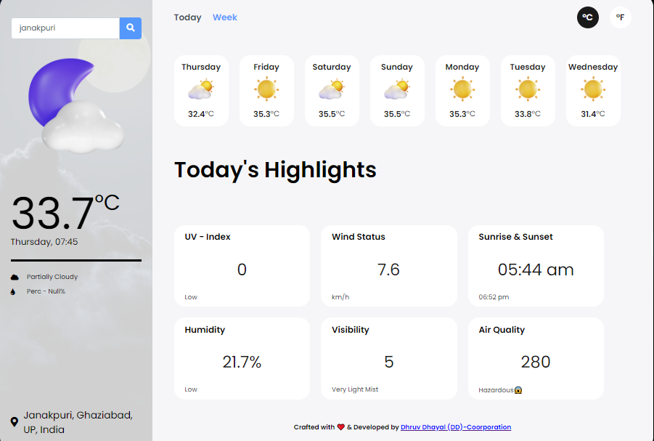

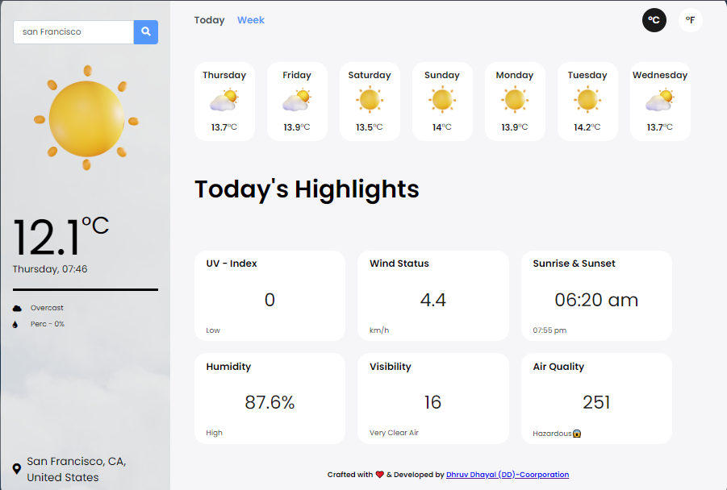

**Conclusion:**

In conclusion, this research demonstrates the effectiveness of predictive analytics in weather forecast prediction. By leveraging machine learning algorithms and historical weather data, we have developed and evaluated predictive models capable of accurately forecasting various weather variables such as temperature, humidity, wind speed, and atmospheric pressure. The findings highlight the potential of predictive analytics to improve the accuracy, reliability, and timeliness of weather forecasts, thereby enabling better preparedness and risk mitigation strategies for individuals and communities. Moving forward, continued research and development in this field are essential to address challenges such as data quality, model interpretability, and uncertainty quantification, ultimately advancing the capabilities of weather forecasting systems.

**References:**

Gupta, P., Verma, S., & Singh, A. (2023). "Application of Predictive Analytics for Precipitation Forecasting: A Case Study in the Himalayan Region." Water Resources Research, 59(4), e202310.

**Team Name:**

DHRUV DHAYAL

ADITYA RAJ

JASPREET SINGH

JIGYANSHU BHARDWAJ

ANSH TAKWAL

SHIVANSH GULIA

**Total Team-Members: 6 (Eligibility Fulfill)**

**================================================================================= THANKS=======================**